**NAV 2016**

*1. Import a new Data Exchange Definition File to support Line items:*

<https://store-nav.readsoftonline.com/>

*2a. Make sure that you have added “Line item processing” to your subscription*.

Capturing line items is a feature that can be enabled by upgrading the Subscription. Click the “My Account” tab and select “My Plan”, then click “Manage Plan” and toggle “Subscription”, and select "Line items processing" in the “Change Plan” section and then select the “Change Plan” button to change the levels

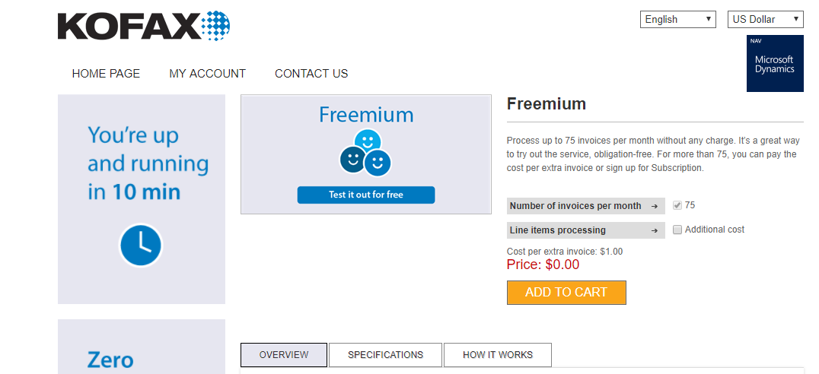

*2b. And that you active Kofax ICS Verify:*

You have to configure your plan in the NAV store. Require verification has three levels; never, uncertain documents only or always. In NAV in Incoming Documents you will notice that the OCR status for the invoice will change to Awaiting Verification.

Click the “My Account” tab and select “My Plan”, then click “Configure”. Activate Kofax ICS Verify by selecting “Uncertain documents only” or “Always”. Select the “Update Configuration” button.

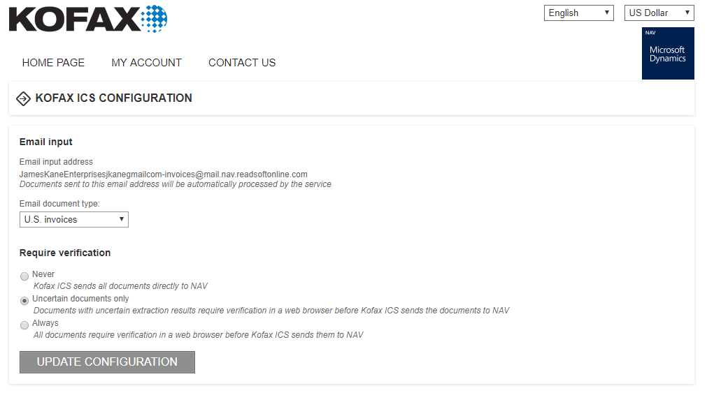

*3a. General Expense invoice*

Go to Incoming Documents

Actions tab > Map Text to Account

Enter “Postage” in Mapping Text and GL account “65800” in the Debit Acc. No. column

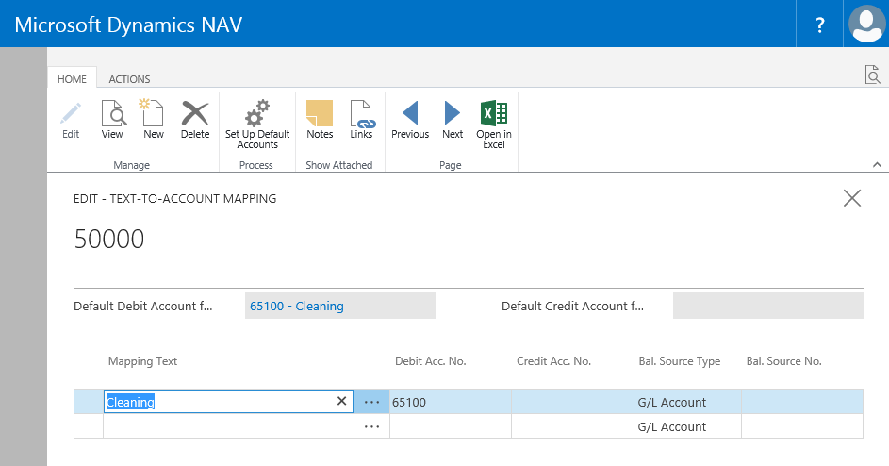

*3b. Line item invoice*

Go to Vendors

Open up the vendor form for “Custom Metals Incorporated”

Actions tab > Cross References

Enter Cross Reference number “FW88” for Item number “1100”, “FH200” for “1150” and “BR767” for “1700”

