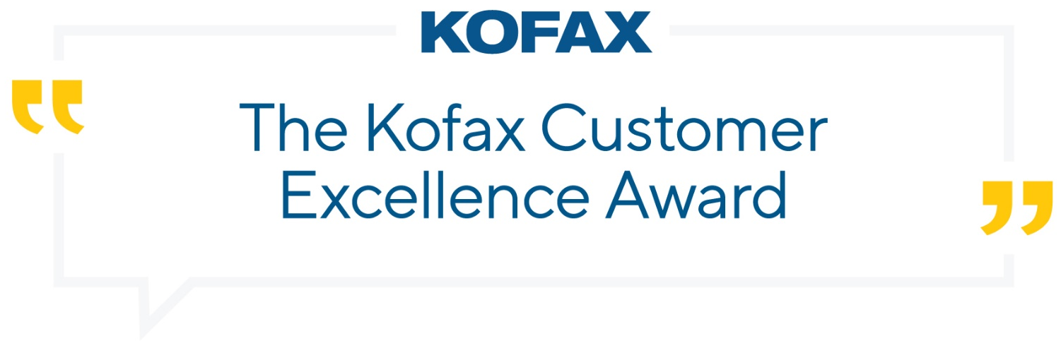

Section 1: General Information
Primary Contact Name
Provide the first and last name for the primary company contact (typically operational program lead)

Primary Contact Title
Provide the title for the primary company contact (typically operational program lead)

Primary Contact Email Address
Provide the email address for the primary company contact

Primary Contact Phone Number
Provide the phone number for the primary company contact

Organization Name
Provide the name of the organization you are nominating

Industry
Provide the industry in which the organization does business

Number of Employees
Provide the approximate number of employees

Section 2: Category Nomination
Indicate the categories the nominee should be recognized for
____ Innovation Excellence
Celebrating technical innovation, most likely with a mix of products brought together in clever and exciting ways to deliver clearly recognizable value. The solution should demonstrate a cutting-edge approach to challenge software boundaries and excite the judges with “The Art of the Possible.”

____ Changemakers
Recognizing customers who deliver big and meaningful changes that transform businesses and/or lives. In terms of technology, these may be simple solutions, but the problems they solve are big. The solution should demonstrate business agility and provide a rapid response to an urgent need, while emphasizing the human value delivered.

____ Lifetime Achievement
Honoring mature customer programs that deliver steady, consistent results over time. Focus on the program approach, best practices developed to deliver repeated success and the overall accumulation of value, with example use cases to illustrate the diversity of operations, both in terms of products used and benefits delivered.

Section 3: Automation Program Information and Details
Tell us about your automation journey. What is your current automation program?
Throughout this application form, please feel free to attach any existing materials you have that answer any questions in any of the sections.
Program Name
Provide the name of the program (The program name you provide is how it will appear in promotional materials. Please be sure to include any trademarks or copyrights)

Program Goals
List the program goals

Departments the Program Covers
Provide the functional areas that are involved in the program

Partner Information (IF APPLICABLE)
Partner Organization Name
Provide the name of the partner organization

Primary Contact Name
Provide the first and last name for the primary partner contact

Program Details
Briefly describe the program
In terms of structure, team distribution, key roles, methodology, and governance

When did the program start?

Name the Kofax and other products used

Describe how these products are being implemented

Number of employees and locations using the solution

Kofax products in production since (MM/YY)

What specific benefits have been delivered to-date?
If hours of value delivered are measured, please include total amount delivered overall, as well as amount delivered in 2021

How did the solution transform the way the organization does business?
What can the organization do today that it couldn’t do before?

Why Kofax?
Why was the Kofax technology selected for this solution? Explain the advantages over any competitive products, legacy systems or internal solutions that were considered.

Section 4: Use Cases
Please give at least one example of a specific use case that is currently live and in production or one specific workflow you’re proud of that is live.
Process Name

Purpose

What was the manual vs automated processing time?

Other Measurable Benefits
Such as ROI, improved % accuracy, better compliance, cost savings, etc.

Date Live (MM/YY)

Why was this use case so important?

Section 5: What’s Your Tomorrow?
What does it mean to Work Like Tomorrow, today for you and your organization?

Terms and Conditions
____ I agree to the terms and conditions
Download and read here: https://www.kofax.com/-/media/files/awards/awards-terms-and-conditions.pdf

Please Provide the company name, location, and a 1-2 sentence company description
This should reflect how you would like it to appear in the press release or other marketing materials.

Once complete, please email your application form to awards@kofax.com.

